**ENTRY FORM**

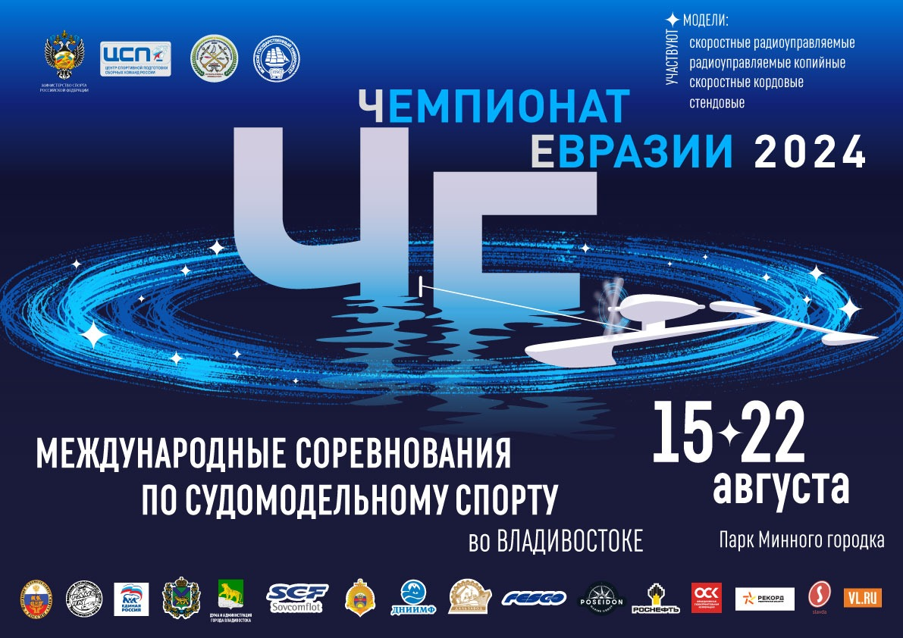

**SMSIF Eurasian Championship**

**2024**

**for ship models in the A/B, NS and M-classes**

**15th to 22th August 2024**

**Vladivostok, Russia**

**SMSIF Eurasian Championship 2024**

**ENTRY FORM for PARTICIPANTS**

1. **1. Name:**
2. **2. First name:**
3. **3. Address:**
5. **4. Country:**
6. **5. National registration number:**

**6. Phone/e-mail:**

1. **7. Day of birth:** Senior: Junior:
2. **8. A/B and M Classes:**

| CLASS | Main model | Reserve model Y/N | Limiter Y/N | Radio control frequency | Transponder YES (ID)/NO | Battery type, configuration and voltage |
| --- | --- | --- | --- | --- | --- | --- |
| ECO Expert mini |  |  |  |  |  |  |
| ECO Expert |  |  |  |  |  |  |
| FSR-E |  |  |  |  |  |  |
| Mono mini |  |  |  |  |  |  |
| Mono I |  |  |  |  |  |  |
| Hydro mini |  |  |  |  |  |  |
| Hydro I |  |  |  |  |  |  |
| A1 |  |  |  |  |  |  |
| A1-E |  |  |  |  |  |  |
| A2 |  |  |  |  |  |  |
| A3 |  |  |  |  |  |  |
| B1 |  |  |  |  |  |  |
| B1-E |  |  |  |  |  |  |

**Eco Team**

|  |  |  |  |  |  |  |
| --- | --- | --- | --- | --- | --- | --- |
| CLASS | Main model | Reserve model Y/N | Limiter Y/N | Radio control frequency | Transponder YES (ID)/NO | Battery type, configuration and voltage |
| Team Pilot 1 |  |  |  |  |  |  |
| Team Pilot 2 |  |  |  |  |  |  |
| Team Pilot 3 |  |  |  |  |  |  |

**Team pilots:** 1.

2.

3.

**Mini Eco Team**

|  |  |  |  |  |  |  |
| --- | --- | --- | --- | --- | --- | --- |
|  | Main model | Reserve model Y/N | Limiter Y/N | Radio control frequency | Transponder YES (ID)/NO | Battery type, configuration and voltage |
| Team Pilot 1 |  |  |  |  |  |  |
| Team Pilot 2 |  |  |  |  |  |  |
| Team Pilot 3 |  |  |  |  |  |  |

**Team pilots:** 1.

2.

3.

**F2/F4 and C classes:**

| CLASS | Prototype name | Scale | Length, mm | Width, mm | Radio control frequency | Battery type, configuration and voltage |
| --- | --- | --- | --- | --- | --- | --- |
| F2-A |  |  |  |  |  |  |
| F2-B |  |  |  |  |  |  |
| F2-C |  |  |  |  |  |  |
| F2-S |  |  |  |  |  |  |
| F4-A |  |  |  |  |  |  |
| F4-B |  |  |  |  |  |  |
| F4-C |  |  |  |  |  |  |
| Demo F-FPV |  |  |  |  |  |  |
| C2 |  |  |  |  |  |  |
| C4 |  |  |  |  |  |  |
| C6 |  |  |  |  |  |  |

**9. Arrival and departures**: by fly railway by car

Flight of train № to Vladivostok Date Time

Luggage size:

Flight or train № from Vladivostok Date Time

Date/Place Participant signature National Federation confirmation stamp